# LAB PROJECT REPORT

# FOR ECE2244: VLSI Design Lab

# TOPIC: Energy Efficient Street Lighting Running on Real Time Clock Using Concept of PWM (Pulse Width Modulation)

SUBMITTED BY :  
Venkat Ram Aryan .P RollNo(42)  
Reg No : 230959128  
Yashas R Kulkarni RollNo(43)  
Reg No : 230959130  
  
BATCH : A2

DEPT.OF ELECTRONICS AND COMMUNICATION (ECE) MANIPAL INSTITUTE OF TECHNOLOGY, MANIPAL-576104

Submitted on 25/03/2025

# INDEX

· Objective

· Introduction

· Project Theory Explanation

· Verilog Code and TestBench

· Results (Waveform/Synthesized Circuit/Layout)

.Conclusion

.References

Objective:

The objective of this project is to design and implement an **energy-efficient street lighting system** that operates based on a **real-time clock (RTC)** and utilizes **Pulse Width Modulation (PWM)** for adaptive brightness control. The system aims to:

**Optimize Energy Consumption** – Adjust the brightness of streetlights dynamically based on the time of day, reducing unnecessary energy usage.

**Enhance Automation** – Implement an RTC-based system that enables lights to turn on/off and adjust brightness without manual intervention.

**Improve Street Safety** – Ensure appropriate lighting levels during peak hours while reducing intensity during low-traffic periods.

**Extend LED Lifespan** – Reduce power stress on LEDs by operating them at lower intensities during non-peak hours.

**Implement Cost-Effective Solutions** – Utilize PWM for smooth dimming control, minimizing power wastage and reducing operational costs.

**Eco-Friendly Approach** – Decrease overall electricity consumption, contributing to sustainable urban development and lower carbon footprints.

Introduction:

Street lighting is essential for safety but consumes significant electricity, often leading to wastage. In **India**, streetlights use over **8,000 GWh** annually, costing municipalities **$500 million**. In smaller cities, it can account for **20% of the municipal budget**.

This project proposes an **energy-efficient street lighting system** using a **Real-Time Clock (RTC)** and **Pulse Width Modulation (PWM)** to optimize brightness based on time. The system **reduces brightness during late hours** to save energy and **automatically turns off at sunrise**.

By implementing **LED lighting with adaptive PWM control**, energy use can be **cut by 60-70%**, significantly lowering costs while promoting sustainability. The system is cost-effective and ideal for **smart city infrastructure**.

Project Theory Explanation:

This project focuses on **energy-efficient street lighting** using **Real-Time Clock (RTC)** and **Pulse Width Modulation (PWM)** to optimize energy consumption. It ensures streetlights operate efficiently by adjusting brightness based on **time schedules** rather than running at full intensity throughout the night.

**Real-Time Clock (RTC) for Time-Based Control**

The **RTC module** maintains accurate time and ensures the streetlights operate at pre-defined schedules.

The system adjusts brightness at specific time intervals:

**Evening (17:30 - 19:00):** Gradual brightness increase.

**Peak Night (19:00 - 05:00):** Full brightness for safety.

**Early Morning (05:00 - 06:30):** Gradual dimming.

**Sunrise (06:30 onwards):** Lights turn off to save energy.

**Pulse Width Modulation (PWM) for Adaptive Brightness**

**PWM controls LED brightness** by adjusting the duty cycle (ON/OFF ratio of the signal).

A **higher duty cycle (e.g., 100%)** means full brightness, while a **lower duty cycle (e.g., 50%)** dims the light.

The system modifies the duty cycle based on time to optimize energy consumption.

**Counter and PWM Signal Generation**

A **counter module** generates an 8-bit value (0-255) to control the PWM signal.

The **Adaptive PWM module** compares this value with a predefined duty cycle to produce the appropriate brightness level.

**Energy Savings and Benefits**

By reducing brightness during off-peak hours, energy consumption is **reduced by 60-70%**.

The system extends **LED lifespan**, lowers **maintenance costs**, and integrates easily with **smart city infrastructure**.

Municipalities save **millions in electricity costs** while maintaining **optimal street lighting conditions**.

Verilog Code and TestBench:

Verilog Code:

module Adaptive_PWM(

input clk, // Clock input

input reset, // Reset input

input [5:0] hour, // Hour input from RTC

input [5:0] minute,// Minute input from RTC

output reg PWM_out, // PWM output

output reg [7:0] duty_cycle

);

wire [7:0] counter_out; // Counter output

reg [3:0] state; // State machine states

// Counter instance

counter counter_inst(

.clk(clk),

.reset(reset),

.counter_out(counter_out)

);

always @(posedge clk or posedge reset) begin

if (reset) begin

// Reset everything

duty_cycle <= 8'd0;

state <= 4'd0;

PWM_out <= 1'b0;

end else begin

case(state)

4'd0: if (hour == 6'd17 && minute == 6'd30) begin duty_cycle <= 8'd64; state <= 4'd1; end

4'd1: if (hour == 6'd18 && minute == 6'd0) begin duty_cycle <= 8'd128; state <= 4'd2; end

4'd2: if (hour == 6'd18 && minute == 6'd30) begin duty_cycle <= 8'd192; state <= 4'd3; end

4'd3: if (hour == 6'd19 && minute == 6'd0) begin duty_cycle <= 8'd255; state <= 4'd4; end

4'd4: if (hour == 6'd5 && minute == 6'd0) begin duty_cycle <= 8'd192; state <= 4'd5; end

4'd5: if (hour == 6'd5 && minute == 6'd30) begin duty_cycle <= 8'd128; state <= 4'd6; end

4'd6: if (hour == 6'd6 && minute == 6'd0) begin duty_cycle <= 8'd64; state <= 4'd7; end

4'd7: if (hour == 6'd6 && minute == 6'd30) begin duty_cycle <= 8'd0; state <= 4'd0; end

endcase

if (hour >= 6'd7 && hour < 6'd17) begin

PWM_out <= 1'b0; // Turn off PWM only from 7 AM to 5 PM

end else begin

PWM_out <= (counter_out < duty_cycle) ? 1'b1 : 1'b0; // Normal PWM operation

end

end

end

endmodule

module RTC(

input clk,

input reset, // Added reset input

output reg [5:0] hour,

output reg [5:0] minute,

output reg [5:0] second

);

reg [31:0] counter;

always @(posedge clk or posedge reset) begin

if (reset) begin

counter <= 32'd0;

hour <= 6'd17; // Start at 17:00 (5 PM)

minute <= 6'd0;

second <= 6'd0;

end else begin

counter <= counter + 1'b1;

if (counter == 60) begin // 60 clock cycles = 1 second

second <= second + 1;

counter <= 0;

if (second == 59) begin

second <= 0;

minute <= minute + 1;

if (minute == 59) begin

minute <= 0;

hour <= hour + 1;

if (hour == 23) begin

hour <= 0; // Reset hour after 23:59 to 00:00

end

end

end

end

end

end

endmodule

module counter(

input clk, reset,

output reg [7:0] counter_out

);

always @(posedge clk or posedge reset) begin

if (reset) begin

counter_out <= 8'd0;

end else if (counter_out == 8'd255) begin

counter_out <= 8'd0;

end else begin

counter_out <= counter_out + 1'b1;

end

end

endmodule

TestBench Code:

Results:

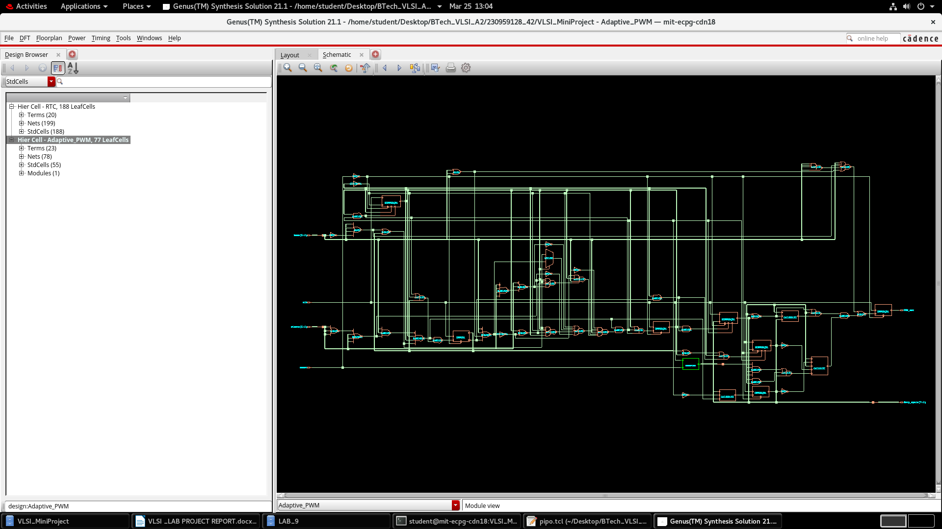

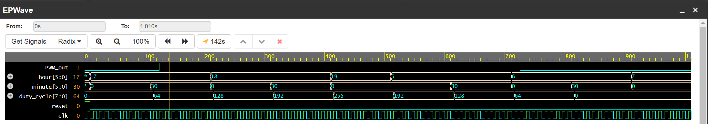

Conclusion:

The **Energy-Efficient Street Lighting System** using **Real-Time Clock (RTC) and Pulse Width Modulation (PWM)** provides a **smart, cost-effective solution** to reduce electricity waste. By **adjusting brightness based on time schedules**, the system ensures **optimal lighting** while significantly **reducing energy consumption** by **60-70%**.

This approach not only **lowers municipal electricity costs** but also **extends LED lifespan**, reduces maintenance, and supports **sustainable urban development**. The implementation of this system can help **modernize street lighting**, making cities **more energy-efficient and environmentally friendly**.

By integrating this solution with **smart city infrastructure**, municipalities can achieve a **greener, more cost-effective future** while ensuring **public safety**.

References:

**Journal of Emerging Technologies and Innovative Research (JETIR)**: <https://www.jetir.org/papers/JETIR2305F22.pdf>

**International Journal of Engineering Applied Sciences and Technology (IJEAST)**: <https://www.ijeast.com/papers/174-178,Tesma412,IJEAST.pdf>

**International Journal of Innovative Research in Electrical, Electronics, Instrumentation and Control Engineering (IJIREEICE)**: <https://ijireeice.com/wp-content/uploads/2024/05/IJIREEICE.2024.12536.pdf>

**JUIT Repository**: [http://ir.juit.ac.in:8080/jspui/bitstream/123456789/7721/1/Smart%20Street%20Lighting%20System.pdf](http://ir.juit.ac.in:8080/jspui/bitstream/123456789/7721/1/Smart Street Lighting System.pdf)

**Thingsquare Blog**: <https://www.thingsquare.com/blog/articles/smart-wireless-led-street-lighting/>

**IJEAST (Auto Intensity Control)**: <https://www.ijeast.com/papers/691-695,Tesma412,IJEAST.pdf>